### Example 7.1
Two speakers are arranged as shown. The distance between them is 3.0 m and they emit a constant tone of 344 Hz.
A microphone P is moved along a line parallel to and 4.0 m from the line connecting the two speakers.
It is found that a tone of maximum loudness is heard and displayed on the CRO when the microphone is on the center of the line and directly opposite to each speaker.
Calculate the speed of sound.
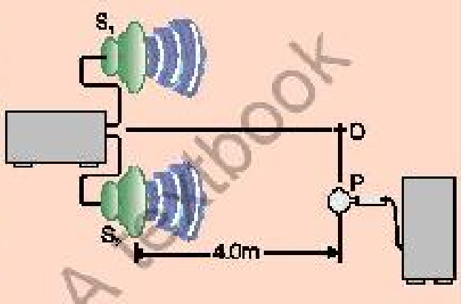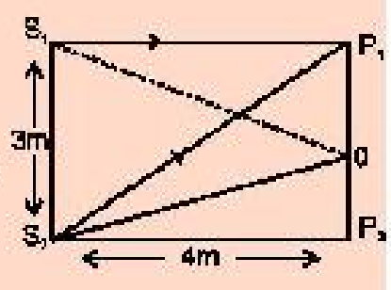
Solution:
Distance between speakers S1 S2 = 3.0 m,
Tone frequency f = 344 Hz,
Distance between speakers and line of motion of P = 4.0 m,
Speed of sound v = ?.
For tone of maximum loudness or the condition for constructive interference, the path difference must be 0, ±λ, ±2λ, ±3λ, ….
At middle point 'O' the path difference between two sound waves is zero (S1 O = S2 O),
thus at that point 'O' constructive interference takes place.
For the next point P of constructive interference, the path difference between waves should be λ.
So, λ = Path difference = S1 P1 - S1 P.
Now, we calculate values of S1 P from right angle triangle S1 S2 P:
S1 P = √(S1 S2)² + (S1 P)² (By Pythagoras Theorem),
S2 P = √(3 m)² + (4 m)² = √(9 + 16) m = √25 m = 5 m.
Therefore, λ = S1 P1 - S1 P or λ = 5 m - 4 m = 1 m.
As v = f λ,
Putting the values, we have v = 344 m s⁻¹ × 1 m = 344 m s⁻¹.

### Example 7.2
The wavelength of a signal from a radio transmitter is 1500 m and the frequency is 200 kHz.
What is the wavelength for a transmitter operating at 1000 kHz and with what speed the radiowaves travel?
Solution:
λ1 = 1500 m = 1.5 × 10³ m,
f1 = 200 kHz = 2.0 × 10⁵ Hz,
f2 = 1000 kHz = 1 × 10⁶ Hz,
λ2 = ?,
v = ?.
Since the speed of both the signals is same, so v = f1 λ1,
v = 2.0 × 10⁵ Hz × 1500 m = 3.0 × 10⁸ m s⁻¹.
Also v = f2 λ2,
λ2 = v / f2 = (3 × 10⁸ m s⁻¹) / (1 × 10⁶ Hz) = 3 × 10² m.

### Example 7.3
A stationary wave is established in a string which is 120 cm long and fixed at both ends.
The string vibrates in four segments at a frequency of 120 Hz.
Determine its wavelength and the fundamental frequency?
Solution:
ℓ = 120 cm = 120 / 100 m = 1.2 m,
n = 4,
fₙ = 120 Hz,
f₁ = ?,
λₙ = ?.
(i) As the string vibrates in four segments and the distance between two consecutive nodes is λ/2,
so the wavelength of the string is:
ℓ = n λₙ / 2,
λₙ = 2 ℓ / n,
λₙ = 2 × 1.2 m / 4,
λₙ = 0.6 m.
(ii) If string vibrates in n loops, then frequency of stationary wave will be:
fₙ = n f₁,
f₁ = fₙ / n,
120 Hz = 4 f₁,
f₁ = 120 Hz / 4,
f₁ = 30 Hz.

### Example 7.4
An organ pipe has a length of 50 cm.
Find the frequency of its fundamental note and the next harmonic, when it is:
(a) open at both ends
(b) closed at one end
(Speed of sound = 350 m s⁻¹)
Solution:
ℓ = 50 cm = 50 / 100 m = 0.5 m,
v = 350 m s⁻¹.
(a) When pipe is open at both ends:
Fundamental frequency f₁ = ?,
Next harmonic frequency f₂ = ?.
The frequency for nth harmonic in an open organ pipe is: fₙ = n v / (2 ℓ) when n = 1, 2, 3, ….
So fundamental frequency is,
f₁ = 1 × 350 m s⁻¹ / (2 × 0.5 m) put n = 1,
f₁ = 350 Hz.
Next harmonic frequency i.e., n = 2 is,
f₂ = 2 v / (2 ℓ),
f₂ = v / ℓ = 350 m s⁻¹ / 0.5 m = 700 s⁻¹,
f₂ = 700 Hz.
(b) When pipe is closed at one end:
Fundamental frequency f₁ = ?,
Next harmonic frequency f₂ = ?.
When the pipe is closed at one end, then frequency for nth harmonic is fₙ = n v / (4 ℓ) when n = 1, 3, 5, 7, ….
So fundamental frequency is,
f₁ = 1 × 350 m s⁻¹ / (4 × 0.5 m) putting n = 1,
f₁ = 175 Hz.
Next harmonic frequency i.e., n = 3 is,
f₃ = 3 v / (4 ℓ),
f₃ = 3 × 350 m s⁻¹ / (4 × 0.5 m) = 525 Hz.

### Example 7.5
A church organ consists of pipes, each open at one end, of different lengths.
The minimum length is 30 mm and the longest is 4 m.
Calculate the frequency range of the fundamental notes.
(Speed of sound = 340 m s⁻¹)
Solution:
ℓ₍min₎ = 30 mm = 30 / 1000 m = 3 × 10⁻² m,
ℓ₍max₎ = 4 m,
v = 340 m s⁻¹,
Frequency range = ?.
For an organ pipe open at one end only:
fₙ = n v / (4 ℓ).
(i) Minimum length
For fundamental frequency, put n = 1,
f₁₍min₎ = v / (4 ℓ₍min₎),
f₁₍min₎ = 1 × 340 m s⁻¹ / (4 × 3 × 10⁻² m),
f₁₍min₎ = 2833.33 Hz.
(ii) Maximum length:
For fundamental frequency, put n = 1,
f₁₍max₎ = v / (4 ℓ₍max₎),
f₁₍max₎ = 1 × 340 m s⁻¹ / (4 × 4 m),
f₁₍max₎ = 21.25 Hz.
So, the fundamental frequency range is approximately from 21 Hz to 2833 Hz.

### Example 7.6
In a ripple tank, a wave generator produces 500 pulses in 10 s.
Find the frequency at time period of the pulses produced?
Solution:
n = 500 pulses,
t = 10 s,
f = ?.
As Frequency = Number of pulses / Time,
f = 500 / 10 s = 50 Hz.
We know that: T = 1 / f = 1 / 50 Hz,
T = 0.02 s.

### Example 7.7
Two tuning forks exhibit beats at a beat frequency of 3 Hz.
The frequency of one fork is 256 Hz.
Its frequency is then lowered slightly by adding a bit of wax to one of its prongs.
The two forks then exhibit a beat frequency of 1 Hz.
Determine the frequency of the second tuning fork.
Solution:
Frequency of first tuning fork = f₁ = 256 Hz,
Beat frequency before loading = 3 Hz,
Beat frequency after loading = 1 Hz,
Frequency of second tuning fork = f₂ = ?.
As f₁ - f₂ = n,
Then f₂ = f₁ ± n,
Putting the values, we have
f₂ = 256 Hz ± 3 Hz,
Either f₂ = 256 Hz + 3 Hz,
or f₂ = 256 Hz - 3 Hz,
f₂ = 259 Hz or 253 Hz.
Let us consider 259 Hz as correct answer (i.e., frequency of second tuning fork).
When first fork is loaded with wax, the frequency of first fork must fall below 256 Hz i.e., 255 Hz, 254 Hz and thus the number of beats produced per second will increase and will be greater than 3 beats.
Since the number of beats per second decreases on loading first fork is one, therefore 259 Hz is not correct frequency of second tuning fork.
Thus, Correct frequency = f₂ = 253 Hz.

### Example 7.8
(a) A wave has an intensity of 0.5 W m⁻² at a distance of 3.0 m from the source.
What is the power of the wave?
(b) Two progressive waves have intensities of 0.5 W m⁻² and 0.25 W m⁻².
Find total intensities of two waves.
Solution:
(a)
I = 0.5 W m⁻²,
r = 3.0 m,
P = ?,
I = P / A,
I = P / (4 π r²),
Putting the values, 0.5 W m⁻² = P / (4 × 3.14 (3.0 m)²),
P = 0.51 × 13.04,
P = 56.52 W.
(b)
I₁ = 0.5 W m⁻²,
I₂ = 0.25 W m⁻²,
I = I₁ + I₂,
I = 0.5 W m⁻² + 0.25 W m⁻²,
I = 0.75 W m⁻².

### Example 7.9
A speaker is emitting sound waves with a power of 50 watts.
If the sound waves are spreading out evenly in all directions and the intensity of the sound waves is measured at a distance of 5 m from the speaker,
what is the intensity of the sound waves if the area of the sphere (the surface area of a sphere) at that distance is approximately 314 m²?
Solution:
Power P = 50 W,
Area A = 314 m²,
Intensity = Power / Area,
I = P / A,
I = 50 W / 314 m²,
I ≈ 0.159 W m⁻².

### Example 7.10
Two trucks P and Q travelling along a motorway in the same direction.
The loading truck P travels at a steady speed of 12 m s⁻¹,
the other truck Q, travelling at a steady speed of 20 m s⁻¹,
sound its horn to emit a steady note which P's driver estimate,
has a frequency of 830 Hz.
What frequency does Q's own driver hear?
(Speed of sound = 340 m s⁻¹)

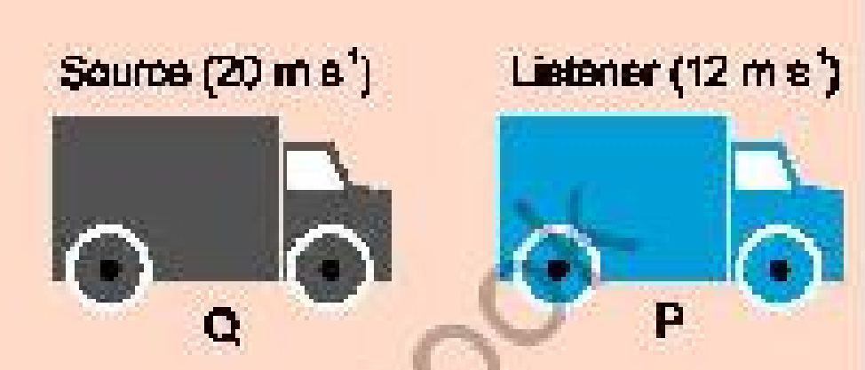
Solution:
uₛ = 12 m s⁻¹,
uₒ = 20 m s⁻¹,
v = 340 m s⁻¹,
fₒ = 830 Hz,
fₛ = ?.
Speed of Q relative to P = uₛ - uₒ = 20 m s⁻¹ - 12 m s⁻¹ = 8 m s⁻¹,
f' = (v / (v - uₛ)) f,
f' = (v / (v - uₒ)) fₒ,
Putting the value, we have
830 Hz = (340 m s⁻¹ / (340 m s⁻¹ - 8 m s⁻¹)) fₒ,
830 Hz = (340 m s⁻¹ / 332 m s⁻¹) fₒ,
or fₒ = (830 Hz × 332 m s⁻¹) / 340 m s⁻¹,
fₒ = 810.47 Hz.

### Example 7.11
A train sounds its horn before it sets off from the station and an observer waiting on the platform estimates its frequency at 1200 Hz.
The train then moves off and accelerates steadily.
Fifty seconds after departure, the driver sounds the horn again and the platform observer estimates the frequency at 1140 Hz.
Calculate the train speed 50 s after departure.
How far from the station is the train after 50 s.
(Speed of sound = 340 m s⁻¹)
Solution:
Time = t = 50 s,
Speed of source (i.e., train) = uₛ = ?,
Distance covered by the train = S = ?.
(i)
f' = (v / (v + uₛ)) f,
Putting the values, we have
1140 Hz = (340 m s⁻¹ / (340 m s⁻¹ + uₛ)) × 1200 Hz,
(340 m s⁻¹ + uₛ) / 340 m s⁻¹ = 1200 Hz / 1140 Hz,
uₛ = 17.89 m s⁻¹.
(ii)
S = (v + uₛ) / 2 t,
S = (0 + 17.89 m s⁻¹) / 2 × 50 s,
S = 448 m.

### Example 7.12
The wavelength of one of its lines of the absorption spectrum of a faint galaxy is identified as Ca-α line found to be 478 nm.
The wavelength of same line is observed and measured as 397 nm in the laboratory.
(a) Is the galaxy moving towards or away from the Earth?
(b) Compute the speed of the galaxy relative to the Earth.
Solution:
Laboratory measured original wavelength λ = 397 nm = 397 × 10⁻⁹ m,
Changed or Apparent wavelength λ' = 478 nm = 478 × 10⁻⁹ m,
Speed of light c = 3 × 10⁸ m s⁻¹.
(a)
v = f λ,
c = f λ (v = c),
f = c / λ,
f = 3 × 10⁸ m s⁻¹ / (397 × 10⁻⁹ m),
f = 7.56 × 10¹⁴ Hz.
Laboratory frequency f = 7.56 × 10¹⁴ Hz,
Apparent frequency f' = c / λ',
f' = 3 × 10⁸ m s⁻¹ / (478 × 10⁻⁹ m),
f' = 6.28 × 10¹⁴ Hz,
λ' > λ or f' < f.
∴ The galaxy is moving away from the Earth.
(b)
f' = (c / (c + u₍g₎)) f (v = c),
Putting the values, we have
6.28 × 10¹⁴ Hz = (3 × 10⁸ m s⁻¹ / (3 × 10⁸ m s⁻¹ + u₍g₎)) 7.56 × 10¹⁴ Hz,
(3 × 10⁸ m s⁻¹ + u₍g₎) / (3 × 10⁸ m s⁻¹) = 7.56 × 10¹⁴ Hz / (6.28 × 10¹⁴ Hz),
u₍g₎ = (22.68 × 10⁸) / 6.28 - 3 × 10⁸ m s⁻¹,
u₍g₎ = 6.12 × 10⁷ m s⁻¹.

—-----------------------------------------------------------------------------------------------------------------

