Example 4.1 A force F acting on an object varies with distance d as shown in Fig. 4.8. Calculate the work done by the force as the object moves from d=0 to d=6 m.

**Solution**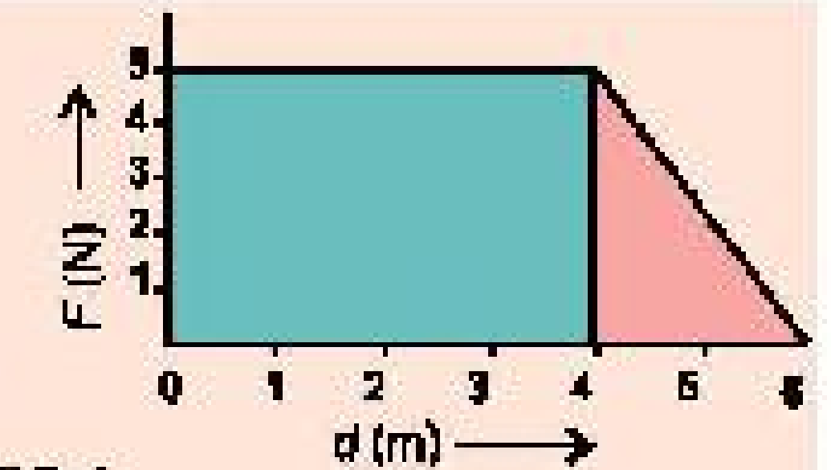
The work done by the force is equal to the total area under the curve from d=0 to d=6 m. This area is equal to the area of the rectangular section from d=0 to d=4 m, plus the area of triangular section from d=4 m to d=6 m.

Hence
Work done represented by the area of rectangle = 4 m x 5 N
= 20 N m = 20 J

Work done represented by the area of triangle = 1/2 x 2 m x 5 N
= 5 N m = 5 J

Therefore, the total work done
= 20 J + 5 J = 25 J
………………………………………………………………………………………………………..
Example 4.2 A 70 kg man runs up a long flight of stairs in 4.0 s. The vertical height of the stairs is 4.5 m. Calculate his power output in watts.

**Solution**
Work done = m g h

Power = m g h / t
P = 70 kg x 9.8 m/s² x 4.5 m
P = 3087 J / 4 s
P = 7.7 x 10² kg m²/s³ = 7.7 x 10² W
……………………………………………………………………………………………………………
Example 4.3 A car weighing 18620 N is running with a speed of 16 m/s. Brakes are applied and it is brought to rest in a distance of 80 m. Determine the average force of friction acting on it.

**Solution**
Given that
v = 16 m/s, d = 80 m, w = 18620 N and f = ?

The kinetic energy of the car is equal to the work done by f before stopping, i.e.,
1/2 m v² = f d

Here
m = w / g = 18620 N / 9.8 m/s² = 1900 kg

Putting the value in the above equation, we have
1/2 x 1900 kg x (16 m/s)² = f x 80 m
or
f = 3040 N
…………………………………………………………………………………………………………..
Example 4.4 A motorcyclist weighing 60 kg is coasting down a 24° slope. The weight of motorcycle is 30 kg. At the top of the slope, the speed of motorcycle is 3.2 m/s. If the kinetic frictional force is 100 N, what will be the speed of the motorcycle at the bottom of the slope which is 72 m down?
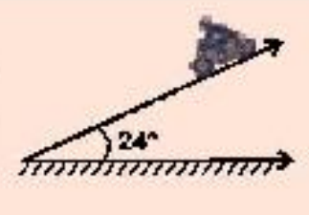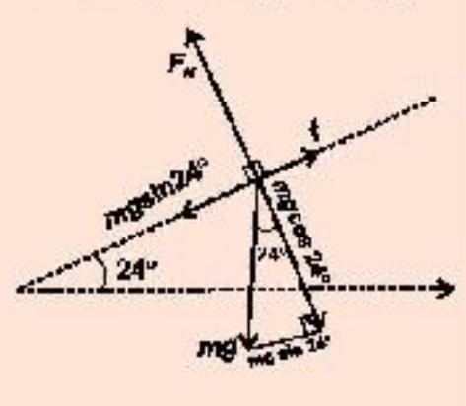

**Solution**
The normal force FN is balanced by the component of weight (m g cos 24°)
perpendicular to the slope. Let the kinetic frictional force be f, then the net force F is:
F = m g sin 24° - f
where m = total mass = 60 kg + 30 kg = 90 kg
or
F = (90 kg x 9.8 m/s² x 0.4) - 100 N
= 352.8 N x 0.4 - 100 N
= 252.8 N

Work done W = F d = 252.8 N x 72 m = 18201.6 J

As work is positive, so applying work-energy theorem,
W = (KEf - KEi)
or here, W = (KEf - KEi)

(KEf = W + KEi)
1/2 m v_f² = W + 1/2 m v_i²
where
1/2 x 90 kg x v_f² = 18201 J + 1/2 x 90 kg x (3.2 m/s)²

This gives,
v_f² = 41.47 m²/s²
or
v_f = √41.47 m/s² = 20.4 m/s
………………………………………………………………………………………………………….
Example 4.5 A 1100 kg car moves at a velocity of 12 m/s when it is at point P. The frictional force is 120 N. What will be its velocity at point Q? It goes beyond Q to come to rest.
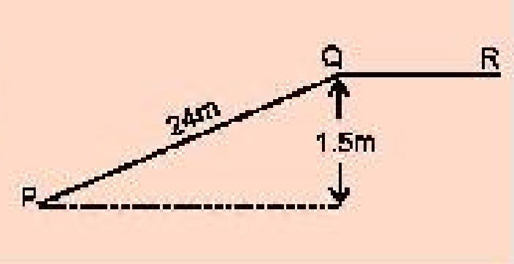

**Solution**
The kinetic energy is partly converted into PE and partly used up in doing work against friction.

Loss of KE = Gain in PE + Work against friction
1/2 m (v_i² - v_f²) = m g h + f d

1/2 x 1100 kg (12² m²/s² - v_f²) = 1100 kg x 9.8 m/s² x 1.5 m + 120 N x 24 m
= 16170 kg m²/s² + 2880 kg m²/s²
= 19050 kg m²/s²

Velocity at point Q,
v_f = √(10.4 m²/s²) = 3.05 m/s

Now if the car stops at point R, then using the formula:
1/2 m v_f² = f s
1/2 x 1100 kg x 10.4 m²/s² = f x s
or
s = 520 kg m²/s² / f ≈ 520 m (approximately)
………………………………………………………………………………………………………….
Example 4.6 An object of mass 3 kg falls from a height of 15 m. If it strikes the ground with velocity of 16 m/s, calculate the average frictional force of the air.

**Solution**
Loss of PE = Gain in KE + Work done against friction
m g h = 1/2 m v² + f h

3 kg x 9.8 m/s² x 15 m = 1/2 x 3 kg x (16 m/s)² + f x 15 m
441 kg m²/s² = 384 kg m²/s² + 15 f
or
f = 441 kg m²/s² / 15 m = 3 kg m/s² = 3 N
………………………………………………………………………………………………………….

