Example 3.1 An electric fan rotating at 3 rev s⁻¹ is switched off. It comes to rest in 18.0 s. Assuming deceleration to be uniform, find its value. How many revolutions did it turn before coming to rest?

**Solution**
In this problem, we have
ω₁ = 3.0 rev s⁻¹, ω₂ = 0, t = 18.0 s and α = ?, θ = ?

From Eq. 3.9, we have
α = (ω₂ - ω₁) / t = (0 - 3.0 rev s⁻¹) / 18.0 s = -0.167 rev s²

and from Eq 3.11, we have
0 = ω₁ t + ½ α t²
3.0 rev s⁻¹ × 18.0 s + ½ (-0.167 rev s²) × (18.0 s)²
= 27 rev
…………………………………………………………………………………………………………..
Example 3.2 If a CD spins at 210 rpm, what is the radial acceleration of a point on the outer rim of the CD? The CD is 12 cm in diameter.

**Solution**
We convert 210 rpm into a frequency in revolutions per second (Hz).
Thus f = 210 rev × (1 min / 60 s) = 3.5 rev/s = 3.5 Hz

For each revolution, the CD rotates through an angle of 2π radians. The angular velocity is:
ω = 2π f = 2π rad × 3.5 s⁻¹ = 7.0π rad s⁻¹

The radial acceleration is:
a = ω² r = (7.0π rad s⁻¹)² × 0.06 m = 29 m s⁻²
…………………………………………………………………………………………………………..
Example 3.3 A ball tied to the end of a string, is swung in a vertical circle of radius r under the action of gravity as shown in Fig. 3.7. What will be the tension in the string when the ball is at point A of the path and its speed is v at this point?
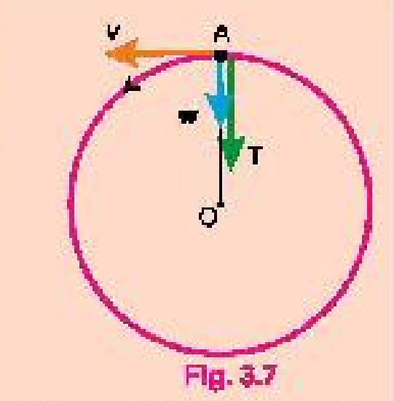
**Solution**
For the ball to travel in a circle, the force acting on the ball must provide the required centripetal force. In this case, at point A, two forces act on the ball, the pull of the string and the weight w of the ball. These forces act along the radius at A, and so their vector sum must furnish the required centripetal force. We, therefore, have
T + w = m v² / r
as w = m g, therefore,
T = m v² / r - m g = m (v² / r - g)

If v² = g r, then T will be zero and the centripetal force is just equal to the weight.
………………………………………………………………………………………………………….
Example 3.4 An Earth satellite is in circular orbit at a distance of 384,000 km from the Earth's surface. What is its period of one revolution in days? Take mass of the Earth M=6.0×10²⁴ kg and its radius R=6400 km.

**Solution**
As
r = R + h = (6400 + 384000) km = 390400 km

Using v = √(GM/r) = √[(6.67×10⁻¹¹ N m² kg⁻²) × (6×10²⁴ kg) / 390400 km]
= 1.025 km/s

Also
T = 2πr / v = 2×3.14 × 390400 km × (1 / 1.025 km s⁻¹) × (1 day / 60×60×24 s)
= 27.7 days
………………………………………………………………………………………………………..
Example 3.5 The mass of Earth is 6.00×10²⁴ kg. The distance r from Earth to the Sun is 1.50×10¹¹ m. As seen from the direction of the North Star, the Earth revolves counter-clockwise around the Sun. Determine the orbital angular momentum of the Earth about the Sun, assuming that it traverses a circular orbit about the Sun once a year (3.16×10⁷ s).

**Solution**
To find the Earth's orbital angular momentum, we must first know its orbital speed from the given data. When the Earth moves around a circle of radius r, it travels a distance of 2πr in one year. Its orbital speed v is thus, v = 2πr / t

Orbital angular momentum of the Earth L = m v r = m (2πr / t) r
L = 2π r² m / t
= 2π (1.50×10¹¹ m)² × (6.00×10²⁴ kg) / 3.16×10⁷ s
L = 2.67 × 10⁴⁰ kg m² s⁻¹

The sign is positive because the revolution is counter-clockwise.
……………………………………………………………………………………………………………

