Example 2.1
Find the angle between two forces of equal magnitude when the magnitude of their resultant is also equal to the magnitude of either of these forces.
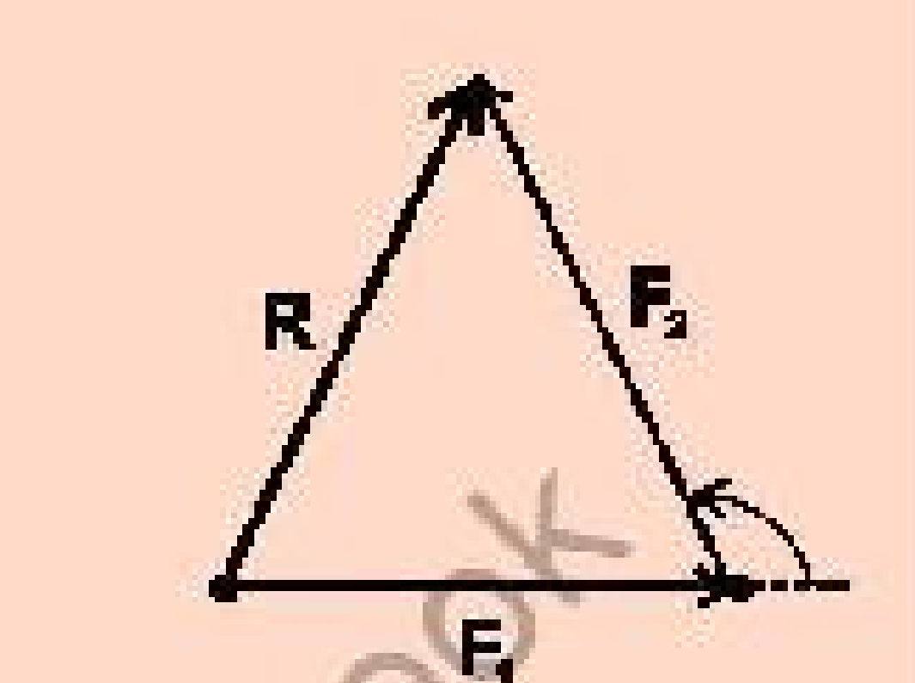
Solution
Let θ be the angle between two forces F1 and F2, where F1 is along the x-axis. Then x-component of their resultant will be:
Rx = F1 cos 0° + F2 cos θ
Rx = F1 + F2 cos θ

And y-component of their resultant is
Ry = F1 sin 0° + F2 sin θ
Ry = F2 sin θ

The resultant R is given by
R² = Rx² + Ry²

As
R = F1 = F2 = F

Hence
F² = (F + F cos θ)² + (F sin θ)²
F² = F² + 2F² cos θ + F² cos² θ + F² sin² θ
or
0 = 2F² cos θ + F² (cos² θ + sin² θ)
or
0 = 2F² cos θ + F²
or
0 = 2F² cos θ + F² · 0 = F² (2 cos θ + 1)

As F ≠ 0, so
2 cos θ + 1 = 0
cos θ = -0.5
θ = cos⁻¹(-0.5) = 120°
………………………………………………………………………………………………………..
Example 2.2
A car travelling at 10 m/s¹ accelerates uniformly at 2 m/s². Calculate its velocity after 5 s.

Solution
vi = 10 m/s¹
a = 2 m/s²
t = 5 s
vf = ?

Using first equation of motion, we can write
vf = vi + a t
vf = 10 m/s + 2 m/s² × 5 s
vf = 10 m/s + 10 m/s¹
vf = 20 m/s¹
……………………………………………………………………………………………………………
Example 2.3
A car travels with initial velocity of 15 m/s¹ and accelerates at a rate of 2 m/s² for 4 seconds. Find the displacement of the car.

Solution
vi = 15 m/s¹
a = 2 m/s²
t = 4 s
Displacement S = ?

By using 2nd equation of motion
S = vi t + ½ a t²

Putting the values
S = (15 m/s × 4 s) + ½ (2 m/s²) (4 s)²
S = 76 m
…………………………………………………………………………………………………………..
Example 2.4
In a short distance race, a contestant in a car starts from rest and reaches the velocity of 300 km/h¹ after covering a distance of 0.45 km at a constant acceleration. Find this constant acceleration.

Solution
Initial velocity vi = 0
Final velocity vf = 300 km/h¹
vf = 300×1000 / 60×60 m/s
= 83.33 m/s¹
Distance covered = S = 0.45 km = 0.45 × 1000 m = 450 m

Using third equation of motion, we have
vf² - vi² = 2 a S
(83.33 m/s)² - (0)² = 2 × a × 450 m
a = 6943.88 m²/s² / 900 m
a = 7.72 m/s²
…………………………………………………………………………………………………………
Example 2.5
An iron ball of mass 1 kg is dropped from a tower. The ball reaches the ground in 3.34 s. Find: (a) the velocity of the ball on striking the ground, (b) the height of the tower.

Solution
Since the ball is falling under the action of gravity, we shall put a = g in equations of motion.
Mass of the ball m = 1 kg
Time taken to reach ground t = 3.34 s
Initial velocity vi = 0
Final velocity vf = ?
Acceleration a = g = 9.8 m/s²

(a) Using first equation of motion:
vf = vi + g t
vf = 0 + (9.8 m/s²) × (3.34 s)
vf = 32.7 m/s¹

(b) Using third equation of motion:
vf² - vi² = 2 g h
(32.7 m/s)² - (0)² = 2 × 9.8 m/s² × h
h = 1069.29 m²/s² / 19.6 m/s²
h = 54.56 m
………………………………………………………………………………………………………….
Example 2.6
A ball is thrown with a speed of 30 m/s¹ in a direction 30° above the horizon. Determine the height to which it rises, the time of flight and the horizontal range.

Solution
Initially
vx = v cos θ = 30 m/s × cos 30° = 25.98 m/s
vy = v sin θ = 30 m/s × sin 30° = 15 m/s

As the time of flight is
t = 2 vy sin θ / g
t = 2×30 m/s × (0.5) / 9.8 m/s²
t = 30 m/s / 9.8 m/s² = 3.1 s

Height
h = vy² sin² θ / 2 g
h = (30 m/s)² × (0.5)² / 19.6 m/s²
h = 11.5 m

Range
R = v² sin 2θ / g = vy² sin 60° / g
R = (30 m/s)² × 0.866 / 9.8 m/s²
R = 79.53 m
………………………………………………………………………………………………………
Example 2.7
A 1500 kg car has its velocity reduced from 20 m/s¹ to 15 m/s¹ in 3.0 s. How large was the average retarding force?

Solution Using the Eq. (2.27)
F × t = m vf - m vi
F × 3.0 s = 1500 kg × 15 m/s¹ - 1500 kg × 20 m/s¹
or
F = -2500 kg m/s²
= -2500 N = -2.5 kN

The negative sign indicates that the force is retarding one.
…………………………………………………………………………………………………….
Example 2.8
Two spherical balls of 2.0 kg and 3.0 kg masses are moving towards each other with velocities of 6 m/s¹ and 4 m/s¹, respectively. What must be the velocity of the smaller ball after collision, if the velocity of the bigger ball is 3.0 m/s¹?

Solution
As both the balls are moving towards one another, so their velocities are of opposite sign. Let us suppose that the direction of motion of 2 kg ball is positive and that of the 3 kg is negative.
The momentum of the system before collision is:
m1 v1 + m2 v2 = 2 kg × 6 m/s + 3 kg × (-4 m/s)
= 12 kg m/s - 12 kg m/s = 0

Momentum of the system after collision = m1 v1' + m2 v2'
= 2 kg × v1' + 3 kg × (-3) m/s

From the law of conservation of momentum
[Momentum of the system]before collision = [Momentum of the system]after collision
0 = 2 kg × v1' - 9 kg m/s
v1' = 4.5 m/s¹
……………………………………………………………………………………………………….
Example 2.9
A 70 g ball collides with another ball of mass 140 g. The initial velocity of the first ball is 9 m/s¹ to the right while the second ball is at rest. If the collision were perfectly elastic, what would be the velocity of the two balls after the collision?

Solution
m1 = 70 g v1 = 9 m/s¹ v2 = 0
m2 = 140 g v1' = ? v2' = ?

We know that:
v1' = (m1 - m2) / (m1 + m2) v1
v1' = (70 g - 140 g) / (70 g + 140 g) × 9 m/s = -3 m/s
v2' = 2 m1 / (m1 + m2) v1
v2' = (2 × 70 g) / (70 g + 140 g) × 9 m/s
v2' = 6 m/s¹
………………………………………………………………………………………………………

